# Methane sensor

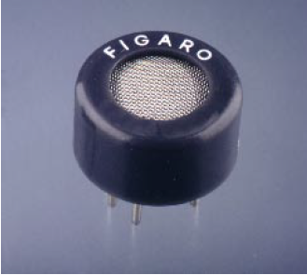

The sensing element of Figaro gas sensors is a tin dioxide (SnO2) semiconductor which has low conductivity in clean air. In the presence of a detectable gas, the sensor's conductivity increases depending on the gas concentration in the air. A simple electrical circuit can convert the change in conductivity to an output signal which corresponds to the gas concentration.

The **TGS 842** has high sensitivity and selectivity to methane. Due to its low sensitivity to alcohol vapors and its low temperature/humidity dependency, the sensor can achieve good reproducibility, making it ideal for domestic gas alarms

The figure below represents typical sensitivity char-acteristics; all data having been gathered at standard test conditions (see reverse side of this sheet). The Y-axis is indicated as sensor resistance ratio (Rs/Ro) which is defined as follows:

Rs = Sensor resistance of displayed gases at various concentrations

Ro = Sensor resistance in 3500ppm methane

**Structure and Dimensions:**

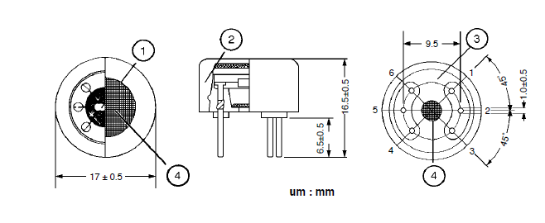

**Basic Measuring Circuit:**

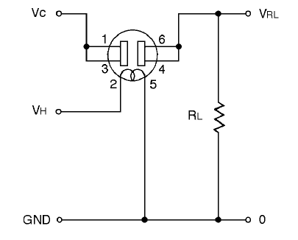

Pin Connection and Basic Measuring Circuit:

The numbers shown around the sensor symbol in the circuit diagram at the right correspond with the pin numbers shown in the sensor's structure drawing (above). When the sensor is connected as shown in the basic circuit, output across the Load Resistor (VRL) increases as the sensor's resistance (Rs) decreases, depending on gas concentration.

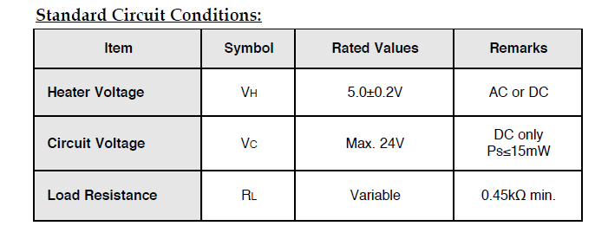

Features:

* High sensitivity to Methane
* Long-term stability
* Low sensitivity to alcohol vapors
* Uses simple electrical circuit

Applications:

* Domestic gas alarms for the detection of methane
* Portable gas detectors